Restaurant Delivery Robot: Lead Engineer Plan


·
Oct 17, 2026
mesfin K

Summary
Fix the physical and electrical base first, because no amount of Nav2 tuning cancels a wheel that leaves the floor. Then build the app against a fake robot so the groups work in parallel. Five decisions matter most:
- Mechanics. Replace the rod between the wheels with independent spring-loaded wheel mounts, and prove it with a 10 mm shim test.
- Power. Use a 10S Li-ion pack with a smart BMS, a fuse, a contactor tied to a mushroom e-stop, and one buck converter per consumer. Check your driver's label first: the 20 to 56 V model suits this.
- Navigation. Add the IMU and an EKF, restore the lidar's field of view, fix the motor loop timing and record the real home pose. Nine findings are listed in the navigation section.
- Architecture. One backend, thin clients, one robot gateway, and a contract frozen in week 1.
- Battery claims. No commercial maker publishes its battery chemistry, so rely on tested practice, not on guessing their cells.
This week: read the driver label, photograph the battery label, weigh the robot, run the odometry calibration and agree the contract.

What commercial restaurant robots build
None of the four robots I checked publishes its battery chemistry, so "what battery do they use" can only be answered by inference. The only voltage I found is 48 V 12 Ah for the W3, on a reseller page. What is published is runtime (9 to 13 hours), charge time (4 to 6.5 hours) and automatic return to a charging dock.

Robot | Sensing and navigation | Battery as published | Payload and speed | Interaction and fleet
Keenon BUTLERBOT | Obstacle detection and | Up to 12 h and about 6.5 h charge | 20 kg, 10 kg per layer; | Enclosed ventilated cabin
W3 | path tracking; | per Keenon's | 0.8 m/s; 48 | with auto-closing
 | rides elevators | page; a reseller | kg | doors; Android;
 | on its own | lists 48 V, 12 Ah; |  | remote control;
 |  | auto-recharge |  | welcome mode
 |  |  |  | with voice
Keenon | 4 stereo vision | Not documented; | 40 kg on | 23.8 inch screen,
DINERBOT | sensors, VSLAM, | 9 to 12.5 h | open trays; | movable head,
T10 | 1 RGB camera, |  | 1 m/s; 58 kg | voice and
 | 360 degree |  |  | expressions,
 | recognition |  |  | advertising
Pudu BellaBot | 3 RGBD | Not stated; 13 h; | 40 kg, 10 kg | Independent
 | cameras, lidar, | 4.5 h charge; quick | per tray; 0.5 | automotive-grade
 | 3D sensors, | battery swap | to 1.2 m/s; | adaptive
 | infrared tray |  | 55 kg | suspension;
 | sensors; dual  SLAM (lidar and |  |  | dozens of facial  expressions;
 | visual) |  |  | PUDU Link app;
 |  |  |  | push-button and
 |  |  |  | 4G watch callers
Bear Robotics | Lidar and | Not stated; 10 to | 30 kg, 2 | 7 inch
Servi | cameras; weight  sensors detect | 12 h; about 4 h  charge; returns to | trays plus a  bus tub; 0.1 | touchscreen; one  trip can serve one
 | that a plate was | home base | to 1.2 m/s | table and clear
 | delivered |  |  | another; multi-
 |  |  |  | robot
 |  |  |  | coordination; NSF certified

App and system architecture
Build one backend that owns orders and robot missions, make every screen a thin client of it, and let one gateway node on the robot be the only bridge to ROS 2. That keeps the app group and the navigation group independent, and lets you replace any screen later.

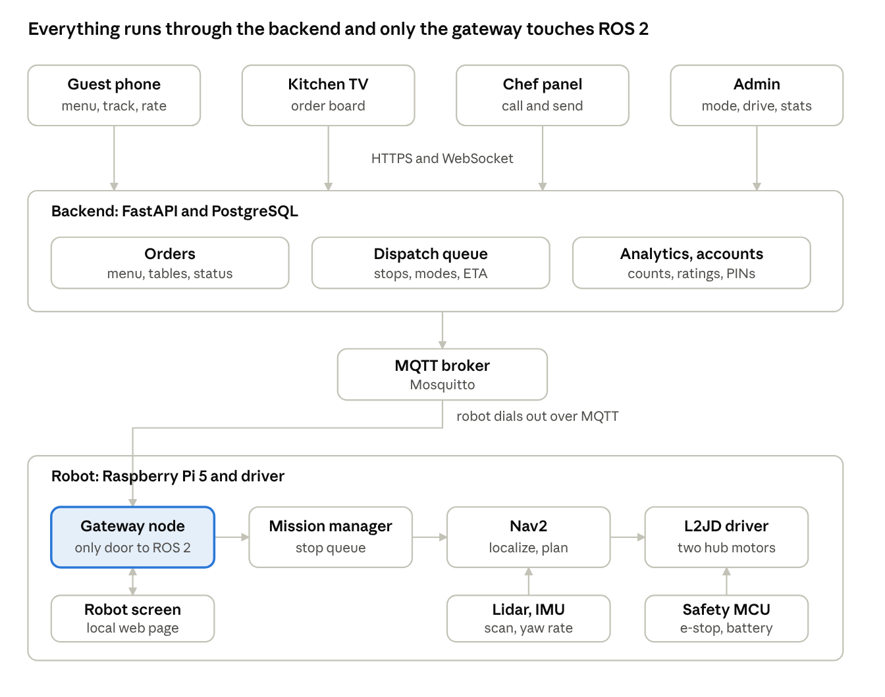
system architecture · 4 clients, backend, broker, robot
Guests, kitchen and staff only ever talk to the backend. The robot dials out to the broker, and the gateway is the single door into ROS 2.

Part | Runs on | Job
Customer menu (web app, no install) | The guest's phone, opened from the table QR code | Browse the menu, order, track the order, rate the meal
Kitchen board | A TV in the kitchen, browser in full screen | Live list of orders with table, items, status, minutes waiting and ETA
Chef panel | A tablet at the pass, and the robot's touch screen | Call the robot, mark plates ready, pick tables in order, send

Part | Runs on | Job
Robot screen | The robot's touch screen, kiosk browser served by the Pi | Face, status, arrival prompt, done button, stars
Admin dashboard | Any browser, login required | Mode switch, manual drive, volume, statistics, menu and table setup
Backend | A restaurant mini-PC or a small cloud server | Orders, dispatch queue, robot link, database, analytics, accounts
Robot gateway | Raspberry Pi 5, a new ROS 2 node | Turns backend commands into ROS 2 calls and reports status and events
Mission manager | Raspberry Pi 5, your existing node, extended | Runs the stop queue, waits for confirmation, docks, recovers

Recommended stack, chosen to keep two people productive:
- Backend: FastAPI (Python) with PostgreSQL, or SQLite while prototyping. Python also suits the gateway, so both share data models.
- Web clients: one React web app with routes for the table menu, kitchen board, chef panel and admin, installable as a PWA.
- Robot link: MQTT through a Mosquitto broker. The robot connects outward, keeps a retained status message, and the broker reports when it drops offline. Browsers get live updates over WebSocket.
- Hosting: guests use mobile data, so host the backend where phones can reach it (a small cloud server or a tunnel). The robot must finish the current delivery if the internet drops.
- ROS 2 stays private: never expose DDS over Wi-Fi to the app. The gateway is the only door.

Screens

Screen | Shows | Main actions
Customer menu | Restaurant name and table number from the QR; category chips; item cards with photo and price; sticky cart bar; then a tracker (Received, Preparing, On the way, Delivered) and a star rating | Add items, place order, rate
Kitchen TV | Four columns: New, Preparing, Ready for robot, On the way. Each card shows table, items, minutes waiting and ETA; colour goes amber then red as it ages; a beep on new orders | Accept, mark preparing, mark ready
Chef panel | A grid of table buttons; tapping one adds a numbered stop, so 5 then 2 means table 5 first | Send, cancel, send home, call robot
Robot screen | Idle: animated eyes and a greeting. Delivering: "Delivering to table 5" with an ETA bar. Arrival: "Table 5, your order has arrived", one large Done button and a countdown. Blocked: "Excuse me, may I pass?". Charging: battery level | Done, stars, staff PIN for the chef panel
Admin | Mode switch (Delivery, Manual, Survey, Maintenance); drive pad with speed slider and rotate; volume slider; map with the robot's position; statistics; menu and table editor; robot log | Switch mode, drive, set volume, edit data
Track these figures from day one: orders and items sold, deliveries completed, average time from order to delivered, average trip time, blocked events, average rating and rating count, battery history, uptime and distance driven.

The contract between the groups
Freeze this in the first week. Each group can then build and test against a fake on the other side.

Direction | Message | Content
Backend to robot | dispatch | delivery id and the stops, as table numbers in order
Backend to robot | cancel, go_dock, set_mode, set_volume | mode is delivery, manual or survey
Backend to robot | teleop | linear speed, angular speed and a speed limit, sent at 10 Hz; the robot stops after  0.5 s of silence
Robot to backend | status, every second | mode, state, battery percent, pose, current delivery and stop
Robot to backend | events | arrived, confirmed (and how), blocked, e_stop, rating, delivery_done
On the robot | tables.yaml | table number mapped to a pose (x, y, yaw), replacing raw coordinates in  /start_mission

Your twist_mux already ranks joystick (100), recovery (50), tracker (20) and navigation
(10). Add an app teleop topic at about 90 with a 0.5 s timeout, so manual drive from the admin page works and navigation yields to it.

Mission manager: what to change
The current node handles a single goal: idle, going to destination, waiting a fixed 15 seconds, returning home, idle. It has no stop queue, no wait for confirmation, no dock or battery logic, no modes and no status output. Extend it with a queue of stops, a confirm wait (done button, tray weight sensor, or a 90 second timeout with voice reminders), services for confirm and set_mode, and a status topic that the gateway forwards.

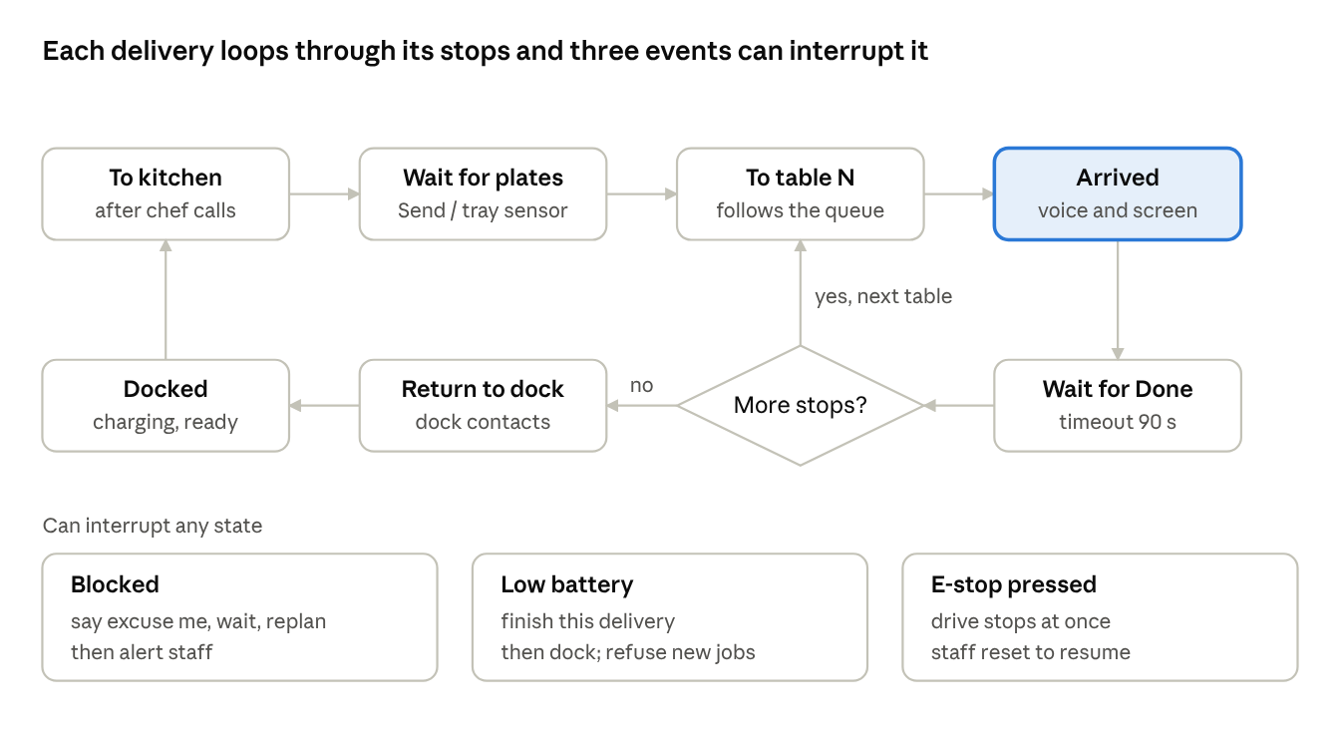
mission states · 7 states, 1 decision, 3 interrupts
The loop from Arrived back to the next table is what the current node lacks; the three interrupts need their own handlers.

Satisfiaction survey
- Run it only in survey mode: no active orders and battery above about 40%.
- Visit tables the backend says were served more than about 15 minutes ago, once per table per visit.
- Show five large stars; if nobody touches the screen for 30 seconds, thank them aloud and leave.
- Store each rating against the table and the order. Also show the same rating page on the guest's phone, because it works even when the robot is busy.

Interaction fieatures and what similar robots do
Commercial robots win guests with small, reliable moments: a face that reacts, a voice at the table, and a plate hand-off that needs no thought. Build the must-haves first; the rest are cheap add-ons once the core works.

Feature | Seen on | Priority | Effort
Arrival message, aloud and on screen, with one large Done button | Voice and expressions on the T10; voice on the W3 | Must | Low
Plate-taken detection with a weight or infrared tray sensor, as a backup to the Done button | Servi weight sensors; BellaBot infrared tray sensors | Must | Medium
Automatic dock and recharge | W3, Servi and BellaBot | Must | Medium
Blocked-path prompt: say "excuse me", wait, replan, then alert staff | Common practice; not on the pages I read | Must | Low
Gentle motion so plates stay put | Servi's stabilizing trays | Must | Low
Animated eyes and facial expressions | Blinking eyes on the W3; dozens of expressions on BellaBot | Should | Low
Status light ring | Light interaction on BellaBot; LED controller in your reference chassis | Should | Low
Local language voice and screen text alongside English | Not on the pages I read | Should | Low
Management app with calling, monitoring and settings | BellaBot's PUDU Link app | Should | You are building this
Guest calls the robot or a waiter with a button or watch | BellaBot push-button caller and 4G watch | Later | Medium
Greeter or usher mode that welcomes and guides guests | W3 welcome mode | Later | Medium
Promotions on the screen | W3 and T10 advertising use | Later | Low
Touch or haptic reaction | BellaBot haptic feedback | Later | Medium
Bussing dirty dishes | Servi's bus tub | Later | High

Feature | Seen on | Priority | Effort
Several robots sharing one floor | Servi fleet coordination | Later | High
Riding the elevator between floors | W3 | Later | High
Enclosed cabin with auto-closing doors for hygiene and privacy | W3 | Later | High

Sources
- Keenon BUTLERBOT W3 product page
- BUTLERBOT W3 reseller listing

- DINERBOT T10 reseller listing
- Pudu BellaBot product page
- Bear Robotics Servi listing (RobotLab)
- Bonnen Batteries robot battery guide (vendor marketing page; cycle-life figures are not independently verified)
- Your files: the L2JD Series user manual and the articubot_one package

